Bayou Velvet Chicken Pasta
Favored With Flavor
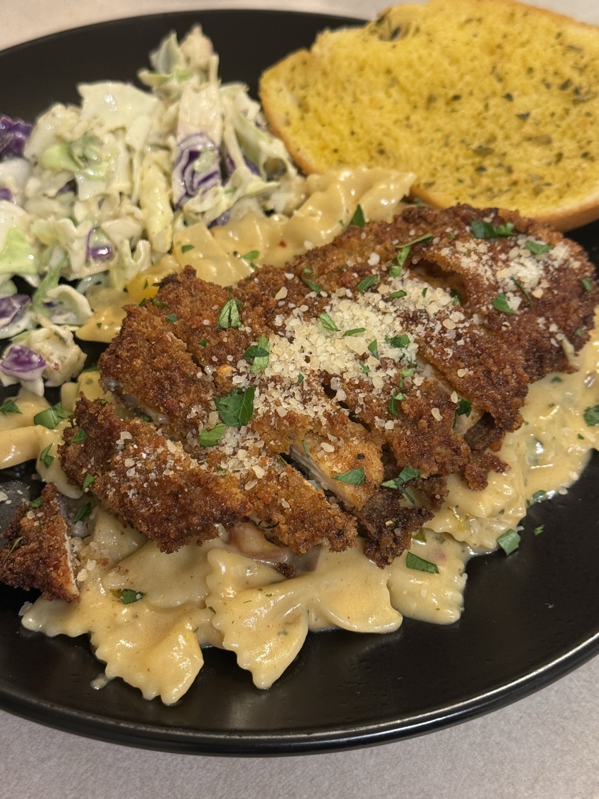
A creamy Cajun-inspired pasta finished with a rich three-cheese sauce and topped with crispy Parmesan-crusted chicken.
Recipe Description
This elevated take on Louisiana Chicken Pasta layers sautéed onions, bell peppers, and mushrooms with Italian herb paste, garlic paste, a splash of white wine, and a velvety cream sauce. Parmesan cheese, garlic and herb Boursin, and extra sharp white cheddar melt together for a rich finish, while the crispy chicken brings the perfect crunch.
Ingredients
Chicken
- 2 thinly sliced chicken breasts
- Salt and black pepper, to taste
- Garlic powder, to taste
- Smoked paprika, to taste
- Cajun seasoning, to taste
- Egg wash
- All-purpose flour
- Breadcrumbs
- Grated Parmesan cheese
- Oil, for frying
Pasta & Sauce
- 12 oz bowtie pasta
- Butter and a little oil
- 1 onion, sliced or diced
- Bell peppers, sliced
- Mushrooms, sliced
- Italian herb paste
- Garlic paste
- Splash of white wine
- Heavy cream
- Chicken broth
- Cajun seasoning, paprika, and crushed red pepper
- Parmesan cheese
- Garlic and herb Boursin cheese
- Extra sharp white cheddar cheese
- Reserved pasta water, if needed
- Parsley and extra Parmesan, for garnish
Step-by-Step Instructions
- Season the thinly sliced chicken breasts with salt, black pepper, garlic powder, smoked paprika, and Cajun seasoning.
- Dip the chicken into the egg wash, then coat it in a mixture of flour, breadcrumbs, and grated Parmesan cheese.
- Place the coated chicken on a tray and let it rest for about 30 minutes so the coating can set and fry up crisp.
- While the chicken rests, boil the bowtie pasta in well-salted water until al dente. Drain and set aside, reserving a little pasta water if needed later.
- Heat oil in a skillet over medium heat and fry the chicken until golden brown, crispy, and cooked through. Remove it from the oil and let it rest.
- In a large skillet, add butter with a little oil. Sauté the onions, bell peppers, and mushrooms until softened and fragrant.
- Stir in the Italian herb paste and garlic paste, letting them cook briefly with the vegetables to build the flavor base.
- Pour in a splash of white wine and let it reduce for a deeper, restaurant-style flavor.
- Add the heavy cream and a little chicken broth. Season with Cajun seasoning, paprika, and crushed red pepper to taste, then let the sauce simmer until slightly thickened.
- Stir in the Parmesan cheese, garlic and herb Boursin, and extra sharp white cheddar cheese until the sauce is smooth, creamy, and fully blended.
- Add the cooked pasta to the sauce and toss until each piece is coated. Use a splash of reserved pasta water if you want the sauce a little looser.
- Slice the crispy chicken and place it over the pasta. Finish with parsley and extra Parmesan, then serve warm.
Serving Notes
Serve with garlic bread and fresh slaw for a complete meal. This dish is perfect for date night, Sunday dinner, or an elevated weeknight meal.
Copyright & Usage Disclaimer
© Favored With Flavor. All rights reserved. This digital recipe is for personal use only. It may not be copied, redistributed, resold, republished, or shared in whole or in part without written permission from Favored With Flavor. Purchasing this file does not transfer copyright ownership. For collaborations, licensing, or business inquiries, please contact Favored With Flavor through your official business channels.

